In Peru the Catholic Church is a cornerstone of their culture. As the Spanish conquered Peru, many mixed their traditional beliefs with Catholicism. For example their Mother Earth would be related to the Virgin Mary of Catholicism. The native religion revolved around worshiping the Sun. Sun translated to Pachamama or Mother Earth. There are very few people in Peru that declare themselves as Atheists or Agnostic.
The biggest social change that effected Peru’s religious beliefs goes all the way back to when the Spaniards had set out to conquer Peru. When Father Valverde met with the head of all the Incas, Atahualpa. He handed him the Catholic Catechism and told him if he followed it and listened to it’s teachings he’d hear the voice of God. Atahualpa said he failed to hear the voice of God and threw the book on the ground. Valverde then called upon the military to attack, “absolving” Atahualpa. This was a huge turning point for religion in Peru.
Machu Picchu is the lost city of the Inca. It’s believed that this city was built for spiritual practices and secret rituals. One of the rituals translated to “The Hitching Post of the Sun” This ceremony was used to bring the Sun and Earth together, essentially tying them together.
The Peruvian government strongly recognizes the Catholic Church as strength in many people’s lives. Catholic clergy and laymen/women receive government stipends and stipends from their church. The government also makes church’s available to many regions to guarantee that as many people can practice as possible. The government allows many funds go towards assisting churches and the people who work for them.
Although there have been drastic changes to the nature based religion that Peruvians followed historically they still incorporate it in their Catholic practices. One main aspect of their old religion is their strong respect to nature.
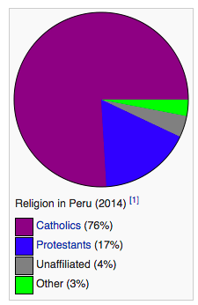
(n.d.). Retrieved March 23, 2015, from http://www.pewforum.org/2014/11/13/religion-in-latin-america/#

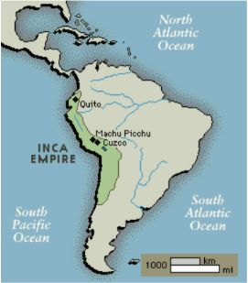
Peru historical information. (n.d.). Retrieved March 23, 2015, from http://www.peru-travel.net/history.htm

Cite Sources:

Peru Overview. (n.d.). Retrieved March 23, 2015, from http://www.adventure-life.com/articles/peru-overview-911

Peru - Religion. (n.d.). Retrieved March 23, 2015, from http://www.amautaspanish.com/destinations/learn-spanish-in-peru/peru-overview/religion-141.html

Famous Historic Buildings & Archaeological Sites in Peru – Machu Picchu, Cusco, Sacred Valley of the Incas. (n.d.). Retrieved March 23, 2015, from http://www.famous-historic-buildings.org.uk/peru_12.html

